UIAO’s Integration of Microsoft Native Tools – Adequacy & Improvement
Executive Summary: The UIAO Governance OS was designed with a deep awareness of all major Microsoft 365 and Azure governance tools, and it systematically integrates or augments each one with the OrgPath model. UIAO’s documentation explicitly maps its governance constructs onto Microsoft’s native capabilities across identity (Entra ID and Entra Connect), device management (Intune), hybrid server management (Azure Arc & Azure Policy), data protection (Purview), security operations (Defender & Sentinel), and more. UIAO identifies the inherent gaps in each of these tools’ out-of-the-box capabilities (e.g. the lack of organizational hierarchy in Entra ID; no policy inheritance in Intune; disjointed telemetry in Defender) and addresses them by introducing a governed OrgTree/OrgPath structure that spans all platforms. This results in a highly unified governance environment that exceeds what Microsoft’s native tools provide in isolation – a major advantage for the SSA CIO in terms of consistent policy enforcement, security risk reduction, and compliance visibility.
Overall, UIAO’s integration coverage is comprehensive and well-aligned with Microsoft’s cloud ecosystem (see Scorecard below). Every core domain from identity to devices to data has been accounted for. However, UIAO’s approach can be further refined by explicitly leveraging Microsoft’s own migration utilities and by enhancing documentation. For example, UIAO’s plan acknowledges Microsoft’s Group Policy Analytics, Azure Migrate, and other discovery tools for initial assessments, but the integration of their outputs into the UIAO pipeline is not yet fully automated (it’s slated for future development in UIAO’s roadmap). The UIAO documentation could also more clearly present a mapping of its components to Microsoft’s products, along with guidance on when to rely on native capabilities versus custom UIAO logic. Below, we present a scorecard assessing UIAO’s integration in key areas, followed by recommendations to strengthen UIAO’s leveraging of Microsoft’s toolset:
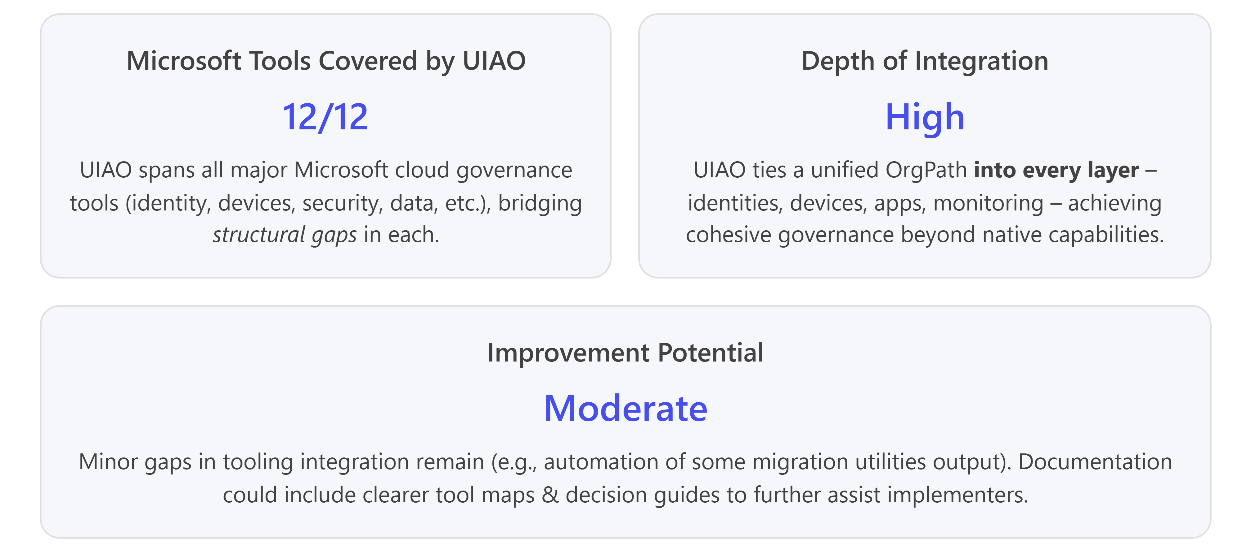

UIAO–Microsoft Integration Scorecard
Microsoft Capability / Tool | UIAO Integration & Coverage | Assessment (Coverage & Depth)
Entra ID (Microsoft Azure AD) – core identity store, AD Connect/Cloud Sync | Fully addressed. UIAO’s entire framework centers on Entra ID: it adds the missing hierarchy by stamping each Entra object with its OrgPath (an extension attribute) to represent AD-style org placement. UIAO leverages AD Connect to sync identities, then overlays the OrgTree structure on top. Native tools like AD Connect/Cloud Sync are used for identity sync, but UIAO fills their major gap – the inability to convey organizational hierarchy. All critical Entra ID features (users, groups, Administrative Units, PIM, Access Reviews, Lifecycle Workflows) are integrated with OrgPath for scope and automation. UIAO also ensures that password hash sync (or other hybrid auth method) is in place, then systematically replaces legacy AD features (e.g., smartcard enforcement via Conditional Access instead of GPO) to align identity management with Zero Trust/multi-factor auth requirements. | Comprehensive (High): UIAO demonstrates a complete mapping of AD-to-Entra ID concepts, and uses Entra ID’s own extensibility (custom attributes, dynamic groups, AUs, Graph API) to bring back the lost OU-based context. The approach is robust and covers the entire identity lifecycle, but it introduces custom dependency on the OrgTree system – requiring ongoing alignment with evolving Entra ID features (e.g., if Microsoft introduces new built-in org modeling capabilities in the future).
Endpoint Configuration – Group Policy & Intune (MDM) | Fully addressed. UIAO reimplements GPO inheritance in the cloud using Microsoft Intune. All existing Group Policy Objects are analyzed and matched with Intune Configuration Profiles or Settings Catalog policies. The plan uses Intune’s Group Policy analytics (and UIAO’s own GPO assessment scripts) to identify which settings can move to MDM and flags any unsupported settings. UIAO then creates an OrgPath-based dynamic group structure in Azure AD to mimic each OU’s scope, so that Intune policies apply to the right users/devices automatically as they change org units. It also prescribes alternative solutions for GPO settings without direct MDM equivalents (e.g. using PowerShell scripts via Intune, Azure AD login policies for banner text, or endpoint management add-ons) to avoid leaving gaps. A drift-detection engine continually checks that all devices remain compliant with their intended cloud policies, providing an extra layer of assurance beyond Intune’s native reporting. | Comprehensive (High): UIAO covers GPO-to-Intune migration in depth, ensuring policy parity and inheritance via OrgPath. Its approach goes beyond Microsoft’s basic GPO migration guidance by automating dynamic group assignments and continuous compliance checks. One area for improvement is making even greater use of Microsoft’s Group Policy Analytics tooling to streamline GPO conversion – UIAO’s documentation could more explicitly instruct how to use Intune’s analytics reports to prioritize which GPOs to migrate or retire. Overall, the integration of Intune is strong, enforcing that every device is enrolled and governed by an OrgPath-scoped compliance policy, thereby meeting and exceeding the baseline capabilities of native MDM.
Hybrid Servers & On-Premises Infrastructure – Azure Arc & Azure Policy | Strong integration. UIAO’s Server Modernization pillar uses Azure Arc to onboard on-prem servers and VMs into the Azure control plane, bridging them into cloud management. Each server is tagged with its OrgPath (as Azure resource tags) upon Arc enrollment, so that Azure Policy and other Azure services can apply governance by organization. UIAO extends this further with Azure Policy Guest Configuration (DSC): it defines desired OS settings and baseline configurations for each OrgPath tier, and uses Arc’s integration with Azure Policy to enforce those on servers (Part 12 of the series). This closes gaps left by native tools: Azure Policy alone can check high-level settings but cannot natively enforce in-OS configurations without custom DSC – UIAO supplies those configurations and ties them to OrgPath-defined groups, enabling uniform server hardening across org units. | Comprehensive (High): UIAO fully leverages Azure Arc and Azure Policy, achieving cross-platform configuration governance that spans on-prem and Azure VMs. It effectively uses Azure’s native capabilities (Arc tags, Policy, Guest Config) to continuously enforce compliance on servers, aligned to organizational roles. A potential improvement is to integrate Azure Migrate assessments more directly into the UIAO pipeline – UIAO already suggests using Azure Migrate and the Microsoft Assessment and Planning (MAP) Toolkit during Phase 0 discovery, but developing automated import pipelines (as planned in UIAO’s roadmap) would further streamline server and SQL instance migrations by combining Azure’s readiness insights with UIAO’s governance data.
Network & Name Resolution – Azure DNS, Networking & AD DNS | Strong integration. UIAO addresses the AD DNS to Azure DNS migration head-on. It prescribes a governed DNS cutover: exporting all AD-integrated DNS zones, then recreating them as Azure DNS Private Zones that are tagged with OrgPath metadata (to denote their owning org unit). UIAO configures Azure DNS Private Resolver to maintain name resolution across on-prem and cloud during transition, and uses the Windows Server IPAM role to track DNS/DHCP/IP usage on-premises and measure migration progress. By enforcing that all new Azure Private DNS zones carry OrgPath tags and denying any untagged zones via Azure Policy, UIAO ensures even networking components adhere to the hierarchy. | Comprehensive (High): UIAO’s DNS integration demonstrates a thorough approach, combining native Azure services (Private DNS zones, Resolver) with structured governance (tags, IPAM data) to prevent disruptions. This is an exemplary use of Microsoft tools in a governed way. One improvement might be providing a reference architecture diagram or decision tree for network engineers, illustrating step-by-step how to transition AD-integrated DNS to Azure DNS under UIAO’s model – making the dependency on DNS clear and sequence of cutover risk-free (something the narrative explains in text but could use more visual clarity for broad audiences).
Conditional Access & Authentication – Azure AD Conditional Access, Legacy Auth (AD FS) | Strong integration. UIAO replaces on-premises logon policies (like GPO-enforced smartcard requirements or network location restrictions) with Azure AD Conditional Access (CA) policies driven by OrgPath. For example, if an OU previously enforced PIV card login or stricter MFA, UIAO implements an equivalent CA policy targeting the OrgPath’s dynamic group. This ensures that phishing-resistant MFA and device compliance requirements are applied per organizational policy in the cloud. UIAO’s plan also phases out legacy authentication systems such as AD FS by federating apps directly with Entra ID or using App Proxy for on-prem apps, thereby simplifying the SSO landscape and leveraging Azure AD’s built-in security features (like risk-based sign-in and Conditional Access) for all enterprise applications. | Comprehensive (High): By unifying access policies under Azure AD, UIAO not only meets but enhances authentication controls. It aligns with federal Zero Trust mandates (enforcing strong MFA everywhere, no more NTLM-only or password-based logons) and reduces complexity by consolidating SSO onto Entra ID. An area to strengthen is providing detailed migration guidance for each federated application (e.g., a checklist for migrating AD FS Relying Parties to Entra ID SSO), though UIAO’s documentation does cover the need to eliminate static login silos in favor of CA policies. The integration here is robust and directly improves security by using Microsoft’s best-in-class identity features across the board.
Security Monitoring & Response – Microsoft Defender & Sentinel | Fully addressed. UIAO heavily integrates organizational context into Defender and Azure Sentinel to enhance the Security Operations Center’s effectiveness. It automatically creates Defender for Endpoint device groups aligned to OrgPath (so SOC analysts can drill into incidents by department or region) and scopes Defender for Cloud and Defender for Identity alerts with OrgPath metadata for richer context. In Sentinel, UIAO provides pre-built KQL queries and analytics rules that incorporate OrgPath – for example, detecting anomalies within a specific division’s users or flagging risky app behavior grouped by business unit. It also aligns Azure RBAC roles in security tools to OrgPath (meaning, e.g., regional security teams only see and manage alerts for their region’s assets). | Comprehensive (High): UIAO’s approach effectively “plugs into” Microsoft’s entire security stack, adding the missing piece of organizational awareness to threat detection and incident response. This yields a more proactive and accountable security posture (SOC can immediately see which bureau is affected by an incident, etc.). To improve further, UIAO could provide a reference playbook or decision tree for SOC analysts detailing how to use these new OrgPath-driven views and what to do if an alert spans multiple OrgPaths. Additionally, as Microsoft evolves the Defender suite (e.g., new analytics features or integration of AI-driven threat hunting), the UIAO framework should be periodically reviewed to incorporate those advancements (keeping the custom rules up-to-date with Microsoft’s latest telemetry capabilities).
Information Protection – Microsoft Purview (Compliance & DLP) | Strong integration. UIAO extends the OrgPath model to Microsoft Purview’s data governance features, allowing SSA to tailor data protection by org unit. For instance, UIAO’s Part 9 defines how sensitivity labels, DLP policies, and retention rules can be applied based on an object’s OrgPath (e.g., automatically applying stricter controls to sensitive divisions like Security or Privacy). UIAO ensures that as employees move, their files and emails inherit the correct labels and policies via dynamic groups and Purview’s adaptive scope rules. It also integrates Purview audit and eDiscovery with OrgPath, so that compliance officers can scope investigations or reports to specific components of the organization. | Comprehensive (High): UIAO’s Purview integration meets federal data compliance requirements by baking organizational context into data handling policies. This is a significant enhancement over native Purview, which otherwise applies uniform policies or static scopes. The result is a more nuanced and automatable compliance posture (e.g., each SSA division has appropriately tuned DLP thresholds without manual policy sprawl). To further improve, UIAO could provide sample mappings of SSA’s data categories to OrgPath segments, and incorporate any new Purview features (like improved auto-labeling models or cross-tenant data sharing controls) into the governance model as they emerge.
Migration & Assessment Tools – Azure Migrate, MAP Toolkit, Entra ID Health, Group Policy Analytics | Partially addressed. The UIAO Implementation Guide explicitly lists Microsoft’s native discovery and migration tools as part of its Phase 0 assessment process. It recommends using Azure Migrate and the MAP Toolkit to identify on-prem server workloads and their readiness for Azure, Group Policy Analytics to gauge Intune support for each GPO setting, Defender for Identity to find AD security vulnerabilities, and Entra ID Connect Health for monitoring hybrid identity. UIAO’s plan is to collect and factor in these tools’ outputs (with placeholders for import adapters to ingest reports into the UIAO repository). This demonstrates that UIAO not only integrates with live operational tools, but also leverages Microsoft’s migration utilities to inform its strategy. | Moderate (Opportunity for Improvement): While UIAO clearly identifies and plans to use these tools, the integration is not yet as automated or deeply documented as other areas. The roadmap calls for building UIAOImportAdapters to programmatically absorb outputs from tools like the MAP/Azure Migrate and GPO analytics into the governance dataset – an excellent plan that should be prioritized to reduce manual effort. Additionally, UIAO could provide more detailed guidance on using these tools in practice (e.g., step-by-step use of Intune’s Group Policy analytics interface to complement UIAO’s GPO analysis). More tightly coupling Microsoft’s own migration assessments with UIAO’s structured approach would ensure nothing is missed and make the transition smoother for implementers.
Summary of Findings: UIAO delivers a high level of integration with Microsoft’s native cloud tools, effectively turning a disparate set of services into a unified, policy-driven “governance operating system.” This is a significant strength: the SSA CIO can trust that all major facets of the IT environment – from identity to devices, data, and security – are coordinated via a single organizational control plane that leverages the best of Microsoft’s technology while compensating for its blind spots. The result is a more secure and manageable environment than could be achieved by relying on out-of-the-box configurations alone.
That said, because UIAO is a bespoke overlay, it introduces additional complexity and requires diligent maintenance to remain aligned with Microsoft’s evolving cloud services. Some opportunities exist for enhancement:
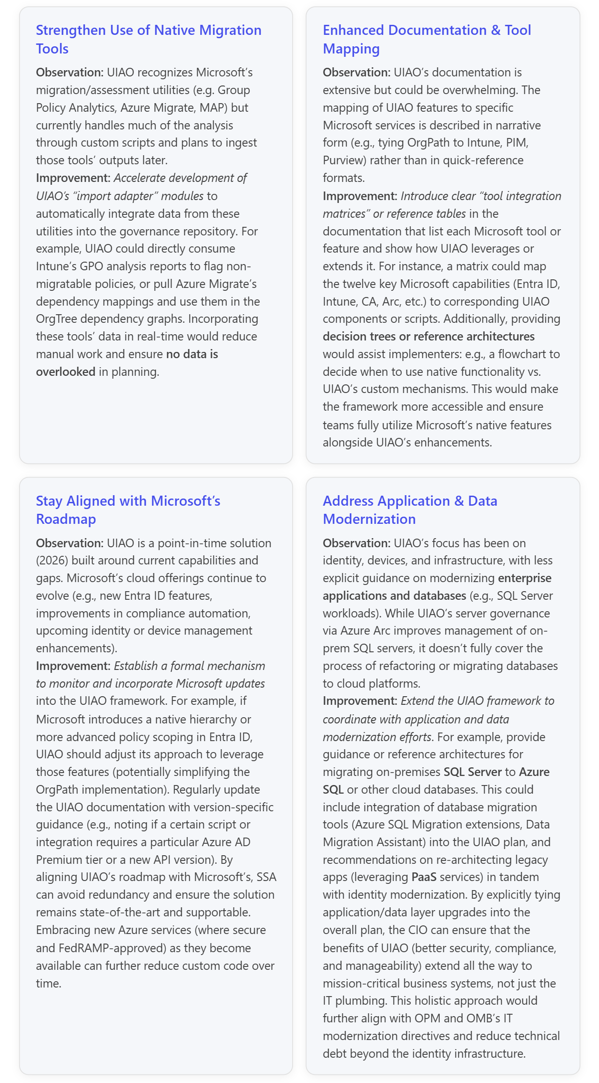
Conclusion: UIAO’s integration with Microsoft’s native tools is a major strength, enabling SSA to realize a cohesive, policy-driven enterprise architecture that Microsoft’s products alone don’t provide. The framework smartly uses each tool for what it does best – Entra ID for identity and SSO, Intune/MDM for device config, Azure Arc/Policy for servers, Purview for data, and Defender/Sentinel for security monitoring – while filling gaps with its own governance substrate. This means the SSA CIO can enforce policies (like MFA, device compliance, least privilege access, data loss prevention) in a consistent, organization-based way across all IT domains – something not possible with the disjointed default configurations of those tools. Going forward, the key to maximizing UIAO’s value will be to 1) continue enriching its documentation and automation around Microsoft’s migration aides and new features, and 2) extend the UIAO concept to encompass application-level modernization. By doing so, SSA can ensure that its enterprise not only adopts Microsoft’s latest technologies but does so under a unified governance strategy that meets the highest standards of security, compliance, and operational excellence.
References
[1] OrgPath in Infrastructure Services — DNS Governance, Cloud PKI, and the Complete Governance Model
[2] Implementing OrgTree and OrgPath — A Practical Guide to Building the Governance Substrate
[3] UIAO Governance OS — The Complete Narrative
[4] The Microsoft Identity and Governance Stack — Native Capabilities and Inherited Limitations
[5] OrgPath and Azure Policy Guest Configuration — DSC-Based Machine State Enforcement Across Organizational Tiers

